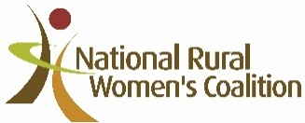
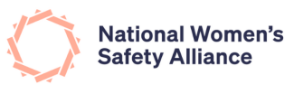
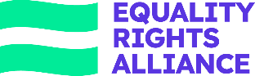

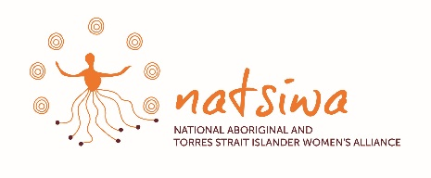
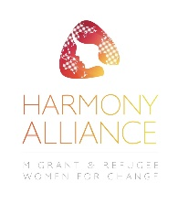
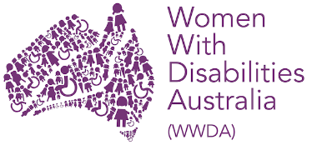

MEDIA RELEASE
Friday 17 May 2024

Budget 2024 – Women’s verdict
The six National Women’s Alliances have expressed support for the focus on women in the Federal Government’s 2024 budget but have also raised serious concerns about whether the measures will bring relief to the most vulnerable women.
This budget is the first to roll out the Federal Government’s commitment to gender analysis, which has resulted in some wins for women. “This budget focuses most of its spending on male-dominated industries such as STEM industries, energy, home building and infrastructure, so it’s good to see some work has been done on the barriers to women entering those sectors. $38.2m for Pathways to Diversity in STEM is welcome, as is $250m for VET training for women” said Helen Dalley-Fisher, Convenor of the Equality Rights Alliance.
“We also welcome the continuing work to remove gender pay gaps in women dominated industries – the promise to fund increases to wages for Early Childhood Education and Training workers is important. The next critical step is the problematically low wages of workers in the community sector. We want to see frontline workers in women’s shelters, homelessness services and community legal centres properly remunerated for the work they do in helping women escape violence and addressing the housing crisis” said Ms Dalley-Fisher.
“For years, our frontline has felt the strain on the domestic, family and sexual violence services, and seen the far-ranging impacts of this lack of funding, lack of transparency and lack of accountability” said Kathryn Berney, Executive Director of the National Women’s Safety Alliance.
“We can argue over dollar amounts but the uncomfortable truth is in a country as wealthy as Australia- what are women’s lives worth? It is the principle of truly valuing the experience of 51% of your population. There is sizeable room for improvement in how we manage the current crisis” said Ms Berney.
“NATSIWA welcomes the continued commitment to improving outcomes for women as outlined in the Federal Budget. We particularly welcome the ongoing support for National Women’s Alliances, who inform the government on intersectional gender equality” said Wendy Anders, CEO of the National Aboriginal and Torres Strait Islander Women’s Alliance.
“As the Peak First Nations Women’s Alliance we look forward to continuing and enhancing our work, with Government and our sister Alliances, in our efforts to empower and elevate First Nations Women’s voices,” said Ms Anders.
“Women With Disabilities Australia welcomes the commitment to the ongoing Leaving Violence Program but is concerned that it does not adequately address the needs and experiences of women with disabilities. Our community must be fully included within mainstream efforts to prevent and respond to gender-based violence,” said Sophie Cusworth, CEO of Women with Disabilities Australia.
“We welcome the investment in the reform of disability employment services and the acknowledgement of the barriers women with disabilities experience in relation to employment. However, we need transformative action to respond to the issues identified throughout the Disability Royal Commission. We continue to call for targeted actions to improve the lives of women with disabilities in Australia and emphasise the importance of engaging directly with our community, including those most marginalised,” said Ms Cusworth.
“Harmony Alliance welcomes women’s safety measures announced in the budget, including $5000 Leaving Violence ongoing payment and inclusion for temporary visa holders leaving violence. However, we could do more to support women on temporary visas, ensuring they have equal access to support and services, such as Centrelink or Medicare,” said Harmony Alliance Chair Nyadol Nyuon OAM.
“Australia has international responsibilities and should have considered the plight of millions of refugee women - especially those listed most at risk by the UN in Afghanistan, Ukraine, Syria, and Palestine. The government should increase supports, including increasing humanitarian intake,” said Ms Nyuon.
“Access to safe pregnancy prevention and termination services for women living in rural, regional and remote women has moved forward with the introduction of ultrasound imaging requests by nurse practitioners to be supported by MBS from 1 November 2024 and changes to the dispensing and prescribing of MS-2Step, the medical abortion drug. We are especially grateful to Assistant Minister Ged Kearney and the National Women’s Health Advisory Council for their advocacy to help access for rural women. We are also delighted to note that a revised Future Drought Fund Communities program will identify rural, regional and remote women as a priority for investment!” said Keli McDonald, CEO of National Rural Women’s Coalition.
“There is also positive news for those of us living in rural, regional and remote Australia with a $43.2million over 5-year investment to support the delivery of communications priorities, including responding to emerging and evolving online harms, boosting regional connectivity, digital inclusion and communications resilience,” said Ms McDonald.
ENDS
For more information and interviews, please contact Helen Dalley-Fisher on 0413 065 822. The National Women’s Alliances are the leading voices for gender equality in Australia. They comprise Equality Rights Alliance (focused on economic security and leadership), National Women’s Safety Alliance, National Aboriginal and Torres Strait Islander Women’s Alliance, National Rural Women’s Coalition, Harmony Alliance (focused on migrant and refugee women) and Women with Disabilities Australia. The membership of these six organisations encompasses the lives of millions of Australian women, girls and other people marginalised by gender.
You can find more information about us and our work here:

National Aboriginal and Torres Strait Islander Women’s Alliance
https://natsiwa.org.au/
Facebook: nationalaboriginaltorresstraitislandwomensalliance
X/Twitter: @NatsiwaCeo
Instagram: natsiwaorg

National Rural Women’s Coalition
https://www.nrwc.com.au/
Facebook: NRWCandNetwork
X/Twitter: @NRWNetwork
Instagram: nrwcnetwork
YouTube: nrwcchannel

Harmony Alliance
https://www.harmonyalliance.org.au/
Facebook: HarmonyAlliance
X/Twitter: @aus_harmony
Instagram: ausharmony
YouTube: @migrationcouncilaustralia5199
Women with Disabilities Australia
https://wwda.org.au/
Facebook: WWDA.Australia
X/Twitter: @WWDA_AU
Instagram: wwd_au
YouTube: @womenwithdisabilitiesaustr7018

National Women’s Safety Alliance
https://nwsa.org.au/
X/Twitter: @nwsaau
Linked In: national-womens-safety-alliance
Instagram: nwsa_au
YouTube: @eraprojects9422

Equality Rights Alliance
www.equalityrightsalliance.org.au
X/Twitter: @eraaustralia
Linked In: Equality-rights-alliance
Instagram: equalityrightsalliance
YouTube: @eraprojects9422

